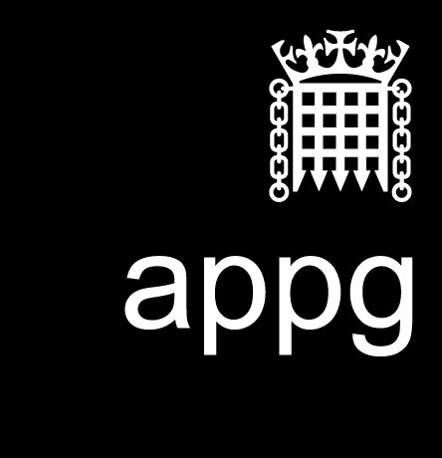
Annual General Meeting
16 December 2025

This is not an official publication of the House of Commons or the House of Lords. It has not been approved by either House or its committees. All-Party Parliamentary Groups are informal groups of Members of both Houses with a common interest in particular issues. The views expressed in this report are those of the group.
Contents
1. Parliamentary Attendance 1
2. Welcome 1
3. Apologies for absence 1
4. The purpose of the group 2
5. Election of Officers 2
6. Report and Financial Statements 5
7. Discussion of future events and priorities for the Group 5

1. Parliamentary Attendance
- Baroness Watkins of Tavistock
- Lord Mohammed
- Baroness Wolf of Dulwich
- Baroness Garden of Frognal
- Baroness Caine of Kentish Town
- Stephen Gethins
- Lord David Willetts
- Lord Norton of Louth
- Daniel Zeichner MP
- Chris Kane MP
- Martin Rhodes MP
- Lauren Edwards MP
- Adam Thompson MP
- Pam Cox MP

2. Welcome
Christine Jardine MP was appointed as external Chair for the meeting, as arranged by the Chair of Ways and Means Committee. She welcomed attendees and explained her role to preside over the mandatory items of business.

3. Apologies for absence
- Afzal Khan MP
- Abtisam Mohamed MP
- Andrew Ranger MP
- Ann Davies MP

4. The purpose of the group
The APPG for Universities provides a cross-party forum in Parliament to champion universities and address issues affecting higher education. It connects policymakers with the sector to shape policy and highlight universities’ economic, social, and research impact.

5. Election of Officers
The following have been nominated for positions and were elected.
Chair:
- Adam Thompson MP
Officers:
- Pam Cox MP
- Andrew Snowden MP
- Stephen Gethins MP
Members:
- Baroness Bonham-Carter
- Baroness Bakewell
- Baroness Blackstone
- Baroness Bottomley of Nettlestone
- Baroness Brinton
- Baroness Brown of Cambridge
- Baroness Deech
- Baroness Finlay of Llandaff
- Baroness Foster of Aghadrumsee
- Baroness Garden of Frognal
- Baroness Hamwee
- Baroness Lawrence of Clarendon OBE
- Baroness Lister of Burtersett
- Baroness Morris of Yardley
- Baroness Northover
- Baroness Prashar
- Baroness Royall of Blaisdon
- Baroness Smith of Llanfaes
- Baroness Smith of Newnham
- Baroness Taylor of Bolton
- Baroness Watkins of Tavistock
- Baroness Wolf of Dulwich
- Baroness Young of Old Scone
- Lord Bilimoria of Chelsea
- Lord Boswell of Aynho
- Lord Darzi of Denham
- Lord Hodgson of Astley Abbotts
- Lord Inglewood
- Lord Johnson of Marylebone
- Lord Liddle
- Lord Lucas
- Lord Mendoza
- Lord Norton of Louth
- Lord Robertson of Port Ellen
- Lord Sewell of Sanderstead
- Lord Storey
- Lord Tarassenko
- Lord Wallace of Saltaire
- Lord Willetts
- Abtisam Mohamed MP
- Adam Jogee MP
- Adam Thompson MP
- Afzal Khan MP
- Andrew Snowden MP
- Carla Denyer MP
- Claire Hughes MP
- Danny Beales MP
- Darren Paffey MP
- Dr Al Pinkerton MP
- Dr Danny Chambers MP
- Dr Scott Arthur MP
- Emily Darlington MP
- Gareth Snell MP
- Gideon Amos MP
- Jack Abbott MP
- Jayne Kirkham MP
- Julie Minns MP
- Lauren Edwards MP
- Martin Rhodes MP
- Mike Reader MP
- Paul Kohler MP
- Perran Moon MP
- Peter Swallow MP
- Rachael Maskell MP
- Rachel Hopkins MP
- Rebecca Long Bailey MP
- Sam Carling MP
- Sian Berry MP
- Stephen Gethins MP
- Steve Race MP
- Tim Roca MP
- Wendy Chamberlain MP
- Zöe Franklin MP
- Pam Cox MP
- Chris Kane MP

6. Report and Financial Statements
The Annual Report and Financial Statement were approved.
The reappointed Chair, Adam Thompson, explained the changes to the group’s financial arrangements and the rationale for the setting of external membership fees.

7. Discussion of future events and priorities for the Group
Adam Thompson chaired a discussion of future events and explained that the Secretariat will be producing an activity plan for 2026 in the coming weeks.
The APPG had a breakfast event scheduled for the 28 January, and an evening reception on 17 March 2026.
Key themes that emerged were:
- University financial stability and insolvency
- Consolidation of providers/mergers and the transformation agenda
- Support for courses unlikely to receive government funding e.g. modern languages, creative subjects and veterinary schools (i.e. Cambridge)
- Universities' civic contribution
- Universities' increasing responsibilities/'load' regarding student mental health
- Immigration and the international student levy

Attendees were given the opportunity to raise the issues they knew to be affecting the sector, and pose questions to the secretariat (Universities UK).


The All-Party Parliamentary University Group was founded in 1994 by MPs and Peers to establish a dialogue between parliamentarians and university leaders on the issues concerning higher education. It is now one of the largest groups in the Palace of Westminster.
The University APPG’s objective is to be the main avenue of communication between parliamentarians and vice-chancellors of the UK’s universities; and to provide an opportunity to examine issues affecting the country’s university sector and university research which is influencing public policy and higher level skills.
The membership consists of senior representatives from UK universities, together with members of the two Houses of Parliament, drawn from all parties. The group has over 90 university members, and over 50 parliamentary members.

July 2021
ISBN: 978-1-84036-421-7
appug@universitiesuk.ac.uk
universityappg.co.uk
@universityappg
linkedin.com/appg-for-universities

